Title: Party Participation Tracker.

Group Members:

1. Kshitij Dhyani 18BIT0131

Mounish , Janesh helped out a lot.

Abstract: This is a service-based project, which helps us conduct the headcount in any kind of get together, club, chapter, group, association, body, crowd, company or participation.

This has a wide range of application and can be actively used actively in the club and chapter meeting in our college itself. We can always see people passing a paper or phone around to manually type name and registration number during every single meeting and association. This is tiresome and dull, here knows our “Party Participation Tracker” which will make this a smooth and fun experience.

Right now the project is limited to a VinnovateIT lab in VIT-Vellore for testing the hypothesis of the need of the product and market alignment of the idea.

In the later versions, one can expect the app to be generalised for all sorts of getting together.

Web Technologies Used :

1.HTML 5

2.CSS 3

3.Java Script

4.MongoDB Atlas

5.Node.js

6.Embedded Javascript

7.Express

8.Mongoose

9.Nodemon

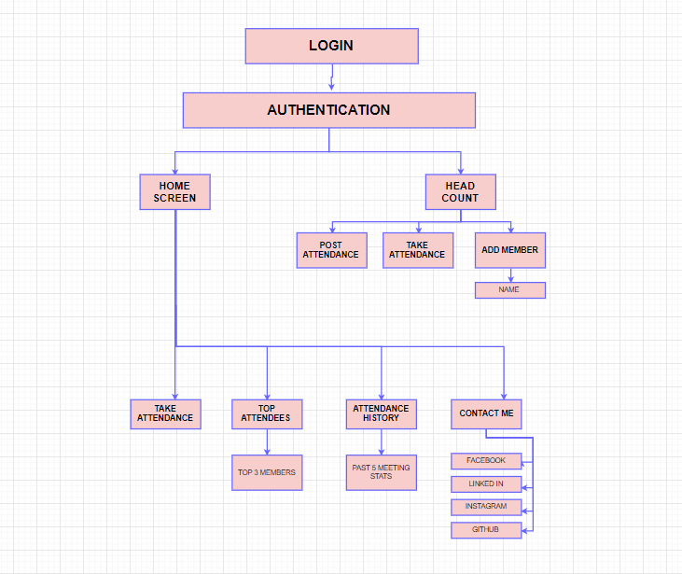

MODULES :

1. The primary thing to do is to authenticate as a user. User will be prompted to enter the username and password if registered, else a signup process will be directed.
2. After Authentication, you will be displayed with the home screen which will have all the details regarding taking attendance, top attendees, attendance history of that particular group associated with that particular authenticated account, contact details.
3. Headcount will have the real attendance taking procedure which will be conducted by enabling the switch against the name of the present student.

Finally, the attendance will be posted and the user will be directed to the home screen where the user can see the reflected results.

IMPLEMENTATION :

LINK TO GIT HUB REPOSITORY: <https://github.com/wimpywarlord/club_attendence_website>

CODE FOR HOME PAGE: <https://github.com/wimpywarlord/club_attendence_website/blob/master/views/viit_attendence.ejs>

CODE FOR ATTENDANCE PAGE: <https://github.com/wimpywarlord/club_attendence_website/blob/master/views/take_att_page.ejs>

CODE FOR BACKEND :

<https://github.com/wimpywarlord/club_attendence_website/blob/master/backend.js>

The database is managed by MongoDB atlas and its always online.

The website has been hosted and published using Heroku in its beta stage and can be actually used with this link :

<https://viit-attendence.herokuapp.com/>

{If the link shows “internal link error” then refresh the page, we are currently working on this bug.}

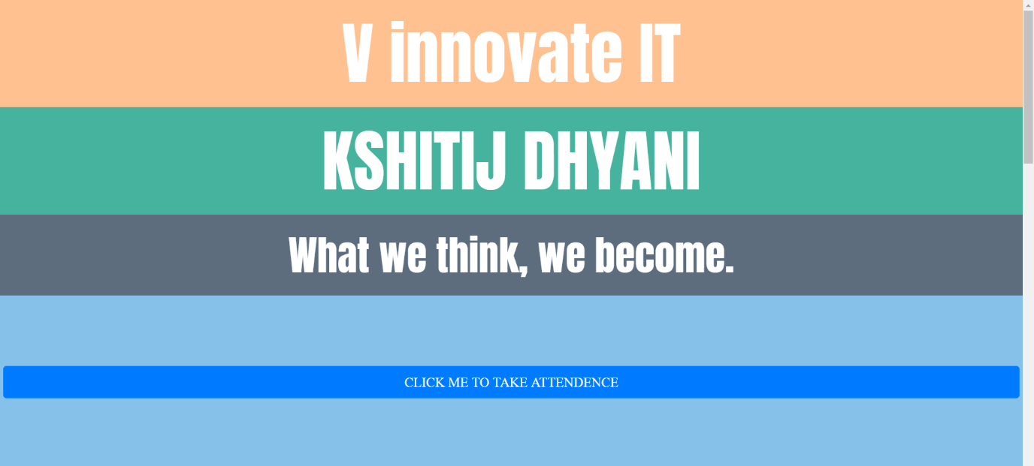



Have fun using our service and website, do star repo on GitHub and show support by connecting with me on social media.